1. Create a program to out the descending order of numbers:

* Sample outputs: **10 9 8 7 6 5 4 3 2 1**

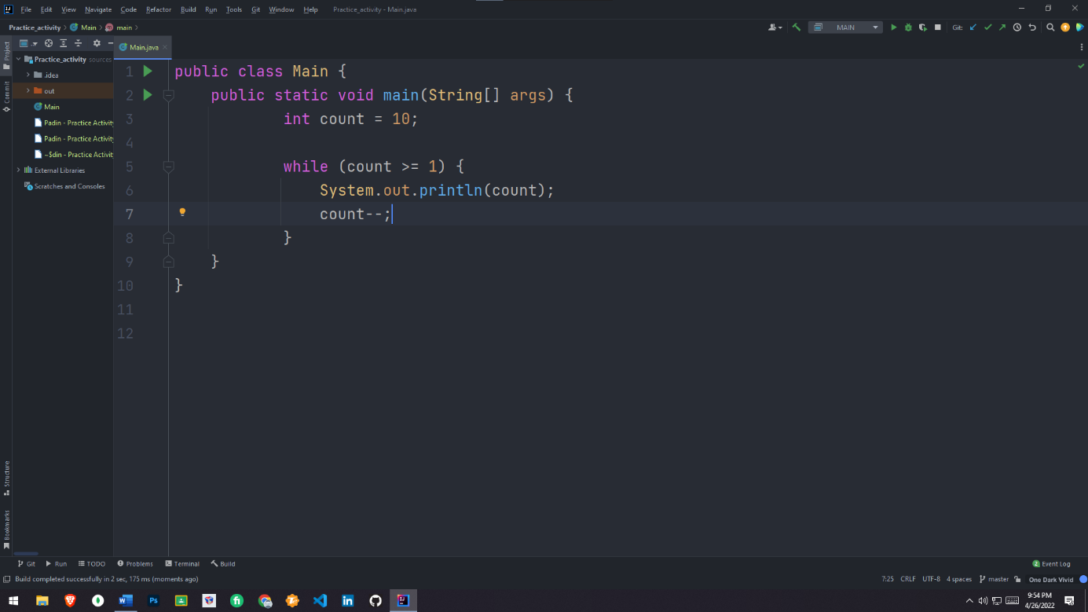SOURCE CODE

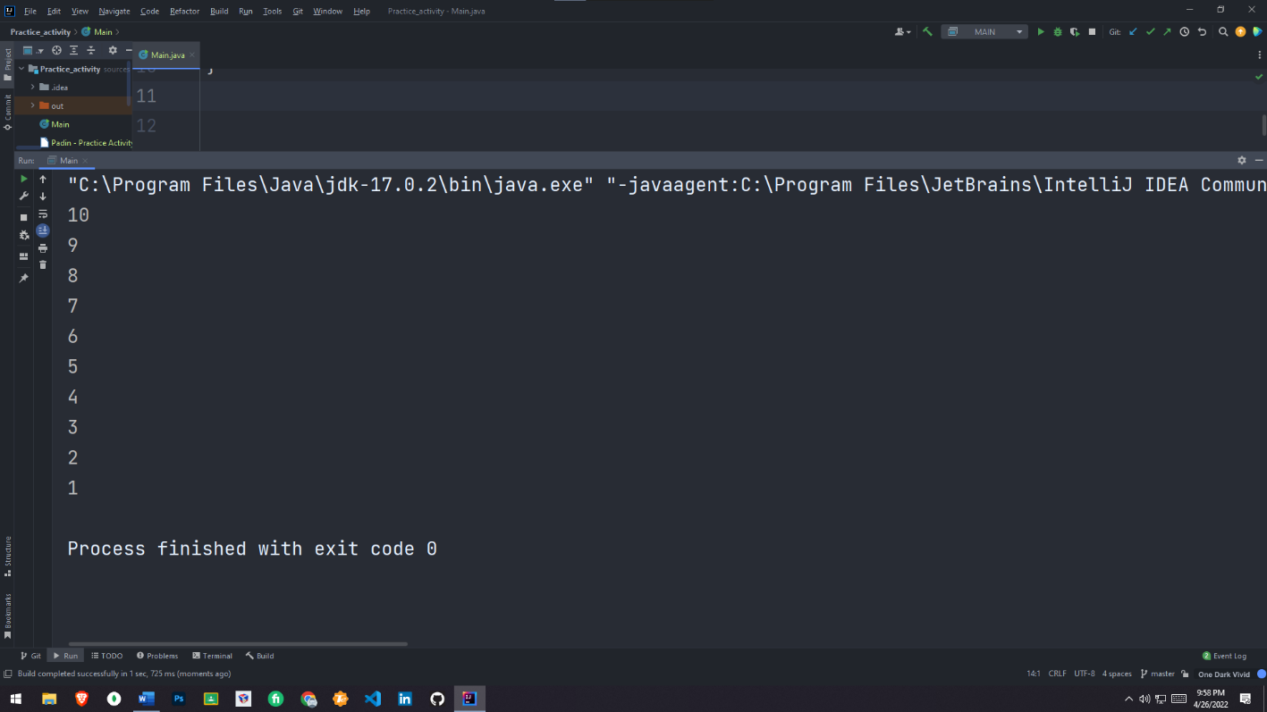OUTPUT

2. Correct the code so that it finds the sum of 10 numbers:

sum = 0;

while (count < 10)

num = console.nextInt();

sum = sum + num;

count++;

SOURCE CODE

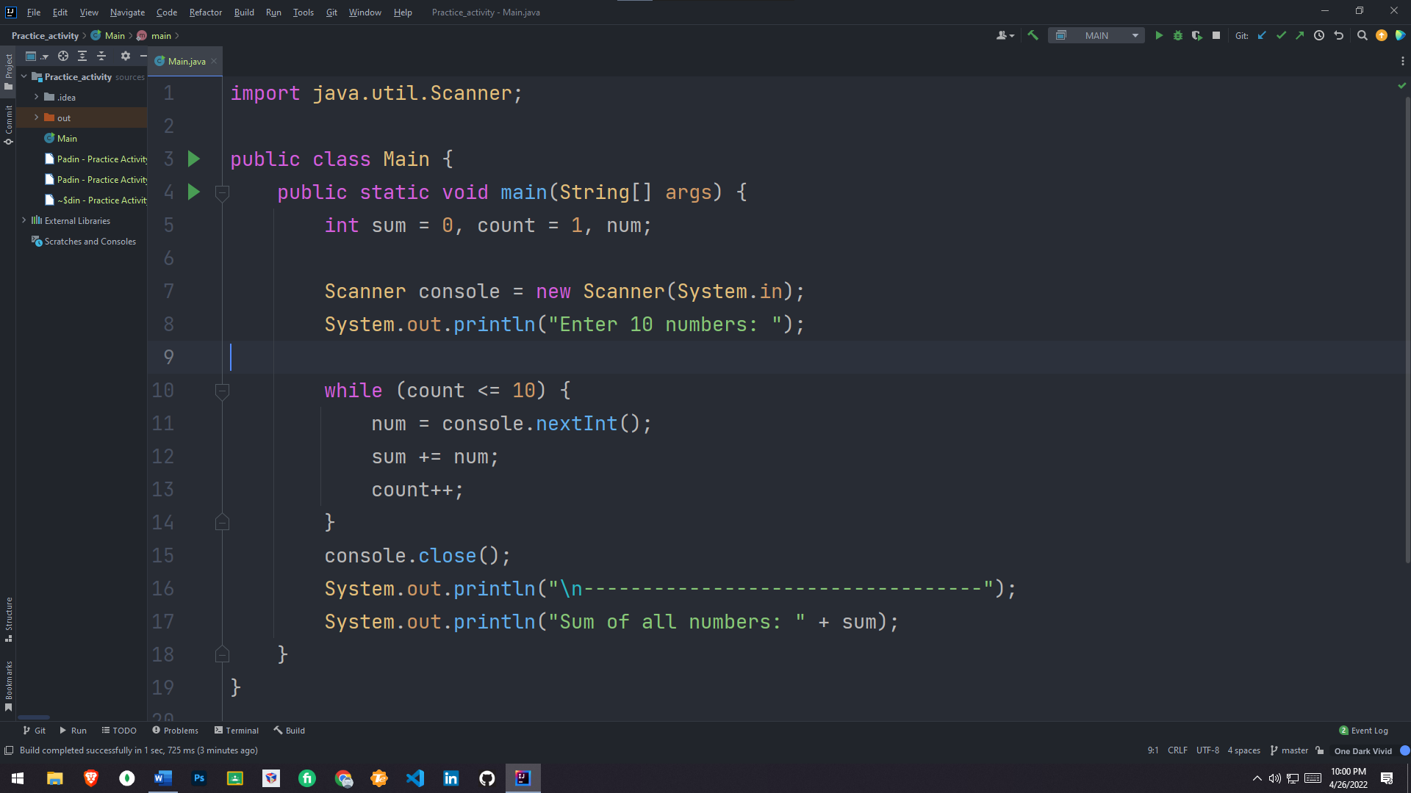

OUTPUT

